**Lab 9-10 – Nanoprocessor Design Competition**

CS1050 Computer Organization and Digital Design

Dept. of Computer Science and Engineering, University of Moratuwa

**Lab Report**

You need to submit a report for this lab. Your report should include the following:

• Student names and index numbers. Do not attach a separate front page.

• State the assigned lab task in a few sentences

• Assembly program and its machine code representation

• All VHDL codes

• All timing diagrams

• Conclusions from the lab

• Clearly describe the contribution of each team member to project and number of hours spent

|  |  |  |
| --- | --- | --- |
|  | Member 01 | Member 02 |
| Name | **Senarathna LPSUK** | **Blasooriya YB** |
| Index Number | **210588U** | **210058V** |

**States of the assigned lab task**

Our main task was constructing a Nano Processor. For achieve this task we had to create necessary components as follows,

• 4-bit Add/Subtract unit

• 3-bit adder -Used to increment the program Counter

• 3-bit Program Counter (PC)-Build using D-flip flop with a reset input

• k-way b-bit multiplexers

Build a 2-way 3-bit multiplexer

Build a 2-way 4-bit multiplexer

Build a 8-way 4-bit multiplexer – using 8 to 1 multiplexer

• Register Bank -contains 7, 4-bit registers, 3-to-8 decoder

• Program ROM

• Instruction Decoder

• LUT_ROM for operating seven segment display

After creating each components we simulated all of them using test bench files in vivado.

After confirming all components are working proper, our next task was combining each components using the **Bus system.**

After combining all components properly, then we test again using test bench code for a sample Assembly code given in lab report for output the addition of numbers in between 1 and 3.

Finally we test the program using **Basys3 board.**

Following figure represents the hierarchy of components.

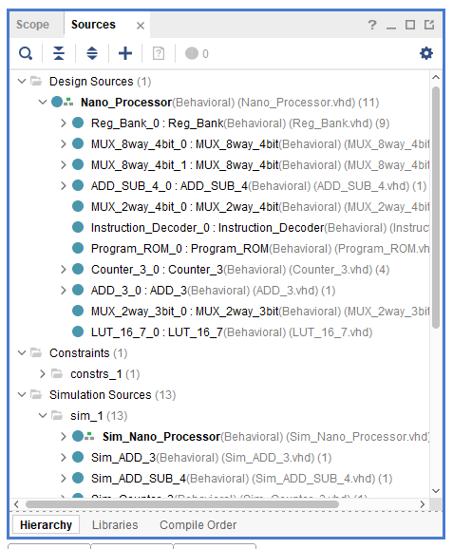

**Conclusions from the lab**

In this lab project, we designed a 4-bit processor capable of performing 4 specific instructions. By completing this lab, we gained the ability to create a 4-bit arithmetic unit for adding and subtracting signed integers. We also learned how to decode instructions to activate the necessary components in the processor. Additionally, we developed the skills to design k-way b-bit multiplexers or tri-state buses for efficient data routing. Through simulation and testing on a development board, we verified the functionality of our design. This team project allowed us to practice important teamwork skills such as communication, coordination, sharing responsibilities, and integrating components developed by different team members. Overall, we acquired valuable knowledge and skills in processor design, teamwork, and practical verification techniques.

**The contribution of each team member**

First we divide the work load of developing each components and work alone for improve the components to functional state.

When there were errors in the components, we get together and discuss how to solve that issues.

Finally all the code files are gathered to a one computer and combine all of them to a top level design and test their functionality using test bench codes and solved the issues discussing together.

After tested it’s functionality using Basys3 board.

number of hours spent - **about 30 hours**